Climate Change Threatens the Biodiversity of the World’s Marine Protected Areas

John F. Bruno1, Amanda E. Bates2, Chris Cacciapaglia3, Beth Pike4, Steven Amstrup5, Ruben van Hooidonk6,7, Stephanie A. Henson8, and Richard B. Aronson3

1 Department of Biology, The University of North Carolina at Chapel Hill, Chapel Hill, NC 27599-3280, USA

2 Ocean and Earth Science, National Oceanography Centre Southampton, University of Southampton, Southampton SO14 3ZH, UK

4 Marie Conservation Institute, Glen Ellen, CA 95442 USA

5 Polar Bears International, P.O. Box 3008, Bozeman, MT, USA 59772

6 NOAA Atlantic Oceanographic and Meteorological Laboratory, Ocean Chemistry and Ecosystems Division, 4301 Rickenbacker Causeway, Miami, FL 33149, USA

7 Cooperative Institute for Marine and Atmospheric Studies, Rosenstiel School of Marine and Atmospheric Science, University of Miami, 4600 Rickenbacker Causeway, Miami, FL 33149, USA

8 National Oceanography Centre, Southampton, SO14 3ZH, UK

**Marine Protected Areas (MPAs)—coastal and open-ocean nature preserves—are a primary management tool designed to mitigate local threats to marine biodiversity**1**. However, MPAs and the species they protect are increasingly being impacted by climate change. Here we show that under Representative Concentration Pathway 8.5, for which emissions continue to rise throughout this century, the mean rate of increase of mean sea-surface temperature (SST) within MPAs is 0.034 °C/year, or roughly 2.8 °C of additional warming by 2100 on average. Projected warming rates increase with latitude, ranging from 0.032 °C per decade for tropical MPAs to 0.038 in polar latitudes. Despite the somewhat slower warming, impacts could be greatest in the tropics due to expected species and habitat losses**2,3**. At mid-to-high latitudes, warming will likely alter species composition and increase species richness as the distributions of species shift pole ward, tracking the displacement of thermal niches.**

**Continuing to follow this business-as-usual emissions pathway would radically disrupt the species and ecosystems currently protected within the worlds MPAs. In addition to their conservation value, MPAs provide immense social and economic benefits to people.**

Thirty years ago Peters and Darling4 warned that nature reserves were threatened by the greenhouse effect. They argued that because of their typically small populations, greatly restricted geographic ranges, and low genetic diversities, species dependent on reserves could be especially sensitive to climate change4. There is growing evidence that Peters and Darling were correct: numerous case studies indicate that anthropogenic global warming is already having substantial effects on populations and ecosystems otherwise protected within terrestrial and marine reserves5,6. This is particularly evident on coral reefs. For example, gradual warming over the last several decades and unusually high seawater temperatures in March and April of 2016 caused mass coral mortality across much of the northern Great Barrier Reef7 (GBR), a UNESCO World Heritage Site and model MPA. Despite its isolation and effective protection from harvesting, pollution, and other stressors, warming radically altered the northern GBR7. This and similar case studies call into question the long-term effectiveness of MPAs in protecting their resident biotas in the face of ocean warming.

We asked how much MPAs can be expected to warm under the business-as-usual trajectory RCP 8.5 and the more optimistic RCP 4.5, for which emissions peak around 2040 and CO2 concentration stabilizes at ~525 ppm in 2100 (and at ~650 ppm for CO2 eq8). We used projections based on CMIP5 model simulations to predict the 21st century rate of change of the mean and maximum SST of the geographic centers of 8236 MPAs around the world (Fig 1A). We compared predicted warming rates of MPAs in different geographic latitudes and ecoregions and to unprotected areas of the oceans. We also assessed warming rate in 309 “no-take reserves” in which fishing is banned.

Under RCP 8.5 mean SSTs are predicted to increase within nearly all MPAs: the average warming rate is 0.034 °C/year (Table 1), with a maximum increase of 0.113°C (in northern Baffin Bay off northwest Greenland). This predicted future warming would be in addition to recent anthropogenic warming of 0.1 °C per decade9, on average, since 1960. Projected warming rates increase slightly with latitudinal zone, from the tropics to polar oceans (Table 1). Remarkably, under RCP 8.5 99% of the world’s MPAs are forecasted to warm by ≥2°C by 2100. Under RCP 4.5 warming rates are substantially lower (Table 1), meaning this degree of mitigation would be ecologically meaningful in terms of a reduction in impacts on marine species and ecosystems10,11.

One potential management response to anthropogenic warming is to position reserves within regions expected to warm less or not at all, i.e., “climate change refugia”12,13. However, forecasted warming rates for MPA in three of the four latitudinal zones roughly match mean background rates (Table 2). The exception is Polar MPAs, for which the rate is far lower than the forecasted background rate of polar oceans. At a smaller scale we found that there was substantial variation among ecoregions in projected warming (Fig. 2A, Table S1) and that warming was unrelated to the number of MPAs within ecoregions (Fig. SX), i.e., MPA placement was not focused on ecoregions with lower rates.

Warming rates are projected to be relatively modest in some ecoregions, including the Hawaiian and Rapa-Pitcairn island groups, and more rapid in others, such as the Gulf of Maine and the Galapagos Islands, where mean SST is predicted to increased by X and X, respectively (by 2100 under RCP 8.5). However, the substantial variation in the inherent thermal sensitivity of constituent species among ecoregions (i.e., thermal bias2), complicates predictions and comparison of regional and local warming impacts. The margin between what a species can tolerate and local maximum temperatures, averaged across all species in a community, is the “Community Mean Warming Buffer”2 (CMWB, Fig. 3B). CMWB in some ecoregions is greater than 5°C, meaning that maximum summertime temperatures would have to increase that much to exceed the estimated tolerance for the average species within the community. By combining the CMWB and the predicted increase in maximum SST (Fig. 2B) we estimated what proportion of tropical and temperate ecoregions would exceed their mean thermal tolerance assuming physiological adjustment (i.e., acclimatization) or adaptation of 2 °C. Temperate ecoregions have a slightly larger buffer but are predicted to warm more, thus a greater proportion (Table S2) of temperate MPAs cross the mean tolerance thresholds (Fig. 2B). Even optimistically assuming the average inhabitant can adapt to warming of 2 °C (which effectively shifts the buffer so that a greater rate of warming is tolerated), xx% of temperate ecoregions still exceed the threshold.

Communities in these ecoregions would likely lose a substantial proportion of of their resident species, whereas new species will presumably colonize as populations track the geographic movement of their thermal niches by shifting their ranges, generally to higher latitudes. Such compositional shifts of temperate communities began at least two decades ago in some locations14 and are now common15,16. In contrast, as tropical communities cross their thermal thresholds, the primary outcome will be biodiversity loss, as there are no climate-migrants to colonize from warmer regions. Thus ocean warming will have fundamentally different impacts on the biotia currently protected in tropical and temperate MPAs.

Several recent studies have combined projected warming rates, species-specific thermal tolerances, and species-distribution and richness patterns to predict changes in species richness and composition globally. For example, Stuart-Smith et al.2 predicted that nearly 100% of extant species will be excluded from tropical reef communities by 2115 under RCP 8.5. Likewise, Molinos et al.3 predicted drastic declines in the regional species pools of tropical marine communities and substantial increases in temperate communities, accompanied by changes in species composition. Shifts in direct or indirect interactions and food-web dynamics can thus be expected along with losses of key facilitators, especially foundation species like kelps and corals, and invasions of new predators, competitors, and parasites 17,18,16. Finally, due to temperature-dependent metabolism of fishes and invertebrates, which are ectotherms, warming will have strong, non-lethal effects on a wide array of population-, community-, and ecosystem-level processes. Cascading impacts of metabolic changes will include developmental and dispersal rates, species interactions, and the standing biomasses of plants and animals19,20.

Not all of these effects will be realized in every reserve. For example, individuals can acclimatize to a degree, and populations can adapt to warming. However, there are limits to the scope and rate of both acclimatization and adaptation, which vary with phylogenetic history, life history, and other biological attributes. Moreover, anthropogenic warming is occurring at an unprecedented rate: 10-100 times more rapidly than has occurred over the last 65 million years21. Carbon emissions are also leading to additional acute and chronic perturbations including ocean acidification, increasing storm intensity, rising sea levels, altered upwelling regimes, and oxygen depletion4,10,11. As a result, organisms must simultaneously adjust their physiologies to cope with multiple threats that in some cases could be selecting for opposing traits. Under RCP 8.5, by 2050 trends in three key emission-driven stressors (warming, acidification, and oxygen depletion) exceed background variability over 86% of the ocean.

Marine biodiversity is already being degraded numerous stressors unrelated to carbon emissions such as by fishing, habitat loss, and pollution. Populations of marine vertebrates, especially predators, have been reduced by 50 to 95%22, and habitat-forming species such as seagrasses, mangroves, and corals are declining by 1–2% annually23–25. Although not a panacea, well-enforced MPAs have been shown to effectively mitigate some of these threats and partially restore marine biodiversity26,27. A recent meta-analysis found that to meet the biodiversity and fisheries goals of MPAs, global coverage needs to be increased from its current extent to 30% or greater28. We support the rapid expansion of fully-protected MPAs and other forms of local conservation such as marine spatial planning, with the critical caveat that local protection is necessary but insufficient to conserve and restore marine biota1. Without drastic reductions in carbon emissions, ocean warming, acidification and oxygen depletion in the 21st century will radically disrupt the composition and functioning of the ecosystem currently protected within world’s MPAs. This would negate decades of progress in conservation and further imperil already threatened species and ecosystems.

**Literature Cited (30 max)**

1. Allison GW, Lubchenco J, Carr MH. Marine reserves are necessary but not sufficient for marine conservation. *Ecol Appl*. 1998;8(sp1).

2. Stuart-Smith RD, Edgar GJ, Barrett NS, Kininmonth SJ, Bates AE. Thermal biases and vulnerability to warming in the world’s marine fauna. *Nature*. November 2015. doi:10.1038/nature16144.

3. García Molinos J, Halpern BS, Schoeman DS, et al. Climate velocity and the future global redistribution of marine biodiversity. *Nat Clim Chang*. 2015;6(1):83-88. doi:10.1038/nclimate2769.

4. Peters RL. The Greenhouse Effect and Nature Reserves. *Bioscience*. 1985;35(11):707-717. doi:10.2307/1310052.

5. Graham N a J, McClanahan TR, MacNeil MA, et al. Climate warming, marine protected areas and the ocean-scale integrity of coral reef ecosystems. *PLoS One*. 2008;3(8):e3039. doi:10.1371/journal.pone.0003039.

6. Monahan WB, Fisichelli NA. Climate exposure of US national parks in a new era of change. *PLoS One*. 2014;9(7):e101302.

7. Hughes TP, Kerry J, Álvarez-Noriega M, et al. Global warming and recurrent mass bleaching of corals. *Nature*. 2017. doi:10.1038/nature21707.

8. van Vuuren DP, Edmonds J, Kainuma M, et al. The representative concentration pathways: an overview. *Clim Change*. 2011;109(1-2):5-31. doi:10.1007/s10584-011-0148-z.

9. Burrows MT, Schoeman DS, Buckley LB, et al. The pace of shifting climate in marine and terrestrial ecosystems. *Science (80- )*. 2011;334(6056):652-655. doi:10.1126/science.1210288.

10. Gattuso J-P, Magnan A, Bille R, et al. Contrasting futures for ocean and society from different anthropogenic CO2 emissions scenarios. *Science (80- )*. 2015;349(6243):aac4722-1-aac4722-10. doi:10.1126/science.aac4722.

11. Henson SA, Beaulieu C, Ilyina T, et al. Rapid emergence of climate change in environmental drivers of marine ecosystems. *Nat Commun*. 2017;8(5020):14682. doi:10.1038/ncomms14682.

12. Cacciapaglia C, van Woesik R. Reef-coral refugia in a rapidly changing ocean. *Glob Chang Biol*. 2015;21(6):2272-2282. doi:10.1111/gcb.12851.

13. McLeod E, Salm R, Green A, Almany J. Designing marine protected area networks to address the impacts of climate change. *Front Ecol Environ*. 2009;7(7):362-370. doi:10.1890/070211.

14. Barry JP, Baxter CH, Sagarin RD, Gilman SE. Climate-related, long-term faunal changes in a california rocky intertidal community. *Science (80- )*. 1995;267:672-675.

15. Wernberg T, Bennett S, Babcock RC, et al. Climate-driven regime shift of a temperate marine ecosystem. *Science (80- )*. 2016;353(6295):169. doi:10.1126/science.aad8745.

16. Poloczanska ES, Brown CJ, Sydeman WJ, et al. Global imprint of climate change on marine life. *Nat Clim Chang*. 2013;3(10):919-925. doi:10.1038/nclimate1958.

17. Aronson RB, Thatje S, Clarke A, et al. Climate Change and Invasibility of the Antarctic Benthos. *Annu Rev Ecol Evol Syst*. 2007;38(1):129-154. doi:10.1146/annurev.ecolsys.38.091206.095525.

18. Burrows MT, Schoeman DS, Buckley LB, et al. The Pace of Shifting Climate in Marine and Terrestrial Ecosystems. *Science (80- )*. 2011;334(6056):652-655. doi:10.1126/science.1210288.

19. Bruno JF, Carr LA, O’Connor MI. Exploring the role of temperature in the ocean through metabolic scaling. *Ecology*. 2015;96(12):3126-3140. doi:10.1890/14-1954.1.

20. Svensson F, Karlsson E, G\a ardmark A, et al. In situ warming strengthens trophic cascades in a coastal food web. *Oikos*. 2017:In press.

21. Diffenbaugh NS, Field CB. Changes in Ecologically Critical Terrestrial Climate Conditions. *Science (80- )*. 2013;341(6145):486. doi:10.1126/science.1237123.

22. McCauley DJ, Pinsky ML, Palumbi SR, Estes J a., Joyce FH, Warner RR. Marine defaunation: Animal loss in the global ocean. *Science (80- )*. 2015;347(6219):247-254. doi:10.1126/science.1255641.

23. Waycott M, Duarte CM, Carruthers TJB, et al. Accelerating loss of seagrasses across the globe threatens coastal ecosystems. *Proc Natl Acad Sci*. 2009;106:12377-12381. doi:10.1073/pnas.0905620106.

24. Polidoro BA, Carpenter KE, Collins L, et al. The Loss of Species: Mangrove Extinction Risk and Geographic Areas of Global Concern. Hansen DM, ed. *PLoS One*. 2010;5(4):e10095. doi:10.1371/journal.pone.0010095.

25. Bruno JF, Selig ER. Regional decline of coral cover in the Indo-Pacific: timing, extent, and subregional comparisons. *PLoS One*. 2007:e711.

26. Edgar GJ, Stuart-Smith RD, Willis TJ, et al. Global conservation outcomes depend on marine protected areas with five key features. *Nature*. 2014;506(7487):216-220. doi:10.1038/nature13022.

27. Lester SE, Halpern BS, Grorud-colvert K, et al. Biological effects within no-take marine reserves : a global synthesis. 2009;384:33-46. doi:10.3354/meps08029.

28. O’Leary BC, Winther-Janson M, Bainbridge JM, Aitken J, Hawkins JP, Roberts CM. Effective Coverage Targets for Ocean Protection. *Conserv Lett*. 2016;0(0):1-6. doi:10.1111/conl.12247.

29. Spalding MD, Fox HE, Allen GR, et al. Marine Ecoregions of the World: A Bioregionalization of Coastal and Shelf Areas. *Bioscience*. 2007;57(7):573-583. doi:10.1641/B570707.

**Table 1.** Projected warming rates of ocean temperatures (mean SST °C / year ± 1 SD) in no-take marine reserves and for MPAs in four latitudinal zones for two different climate models (RCPs). (sample size)

|  |  |  |  |  |  |  |  |
| --- | --- | --- | --- | --- | --- | --- | --- |
| Metric | Model | Reserves  (309) | All MPAs  (8236) | Tropical  (2458) | Subropical  (2738) | Temperate  (2738) | Polar  (166) |
| Mean | 8.5 | 0.033±0.004 | 0.034± 0.006 | 0.032±0.002 | 0.034±0.004 | 0.036±0.007 | 0.038±0.013 |
| Mean | 4.5 | 0.014±0.002 | 0.015±0.003 | 0.014±0.001 | 0.015±0.002 | 0.016±0.004 | 0.019±0.009 |
| Max | 8.5 | 0.035±0.006 | 0.037±0.007 | 0.033±0.002 | 0.037±0.006 | 0.042±0.007 | 0.043±0.011 |
| Max | 4.5 | 0.015±0.003 | 0.016±0.003 | 0.014±0.001 | 0.016±0.003 | 0.018±0.004 | 0.021±0.004 |

**Table 2.** Projected warming rates (mean values and sample size = number of cells) of ocean temperatures (mean SST °C / year ± 1 SD) in MPAs and for the entre region (all cells) in four latitudinal zones for RCP 8.5. Overall mean rate of the global ocean is 0.042 (n=44012 cells).

|  |  |  |  |  |
| --- | --- | --- | --- | --- |
|  | Tropical | Subropical | Temperate | Polar |
| MPAs only | 0.032 (2458) | 0.034 (2738) | 0.036 (2738) | 0.038 (166) |
| Entire region | 0.032 (13289) | 0.031 (8433) | 0.032 (13352) | 0.081 (8938) |

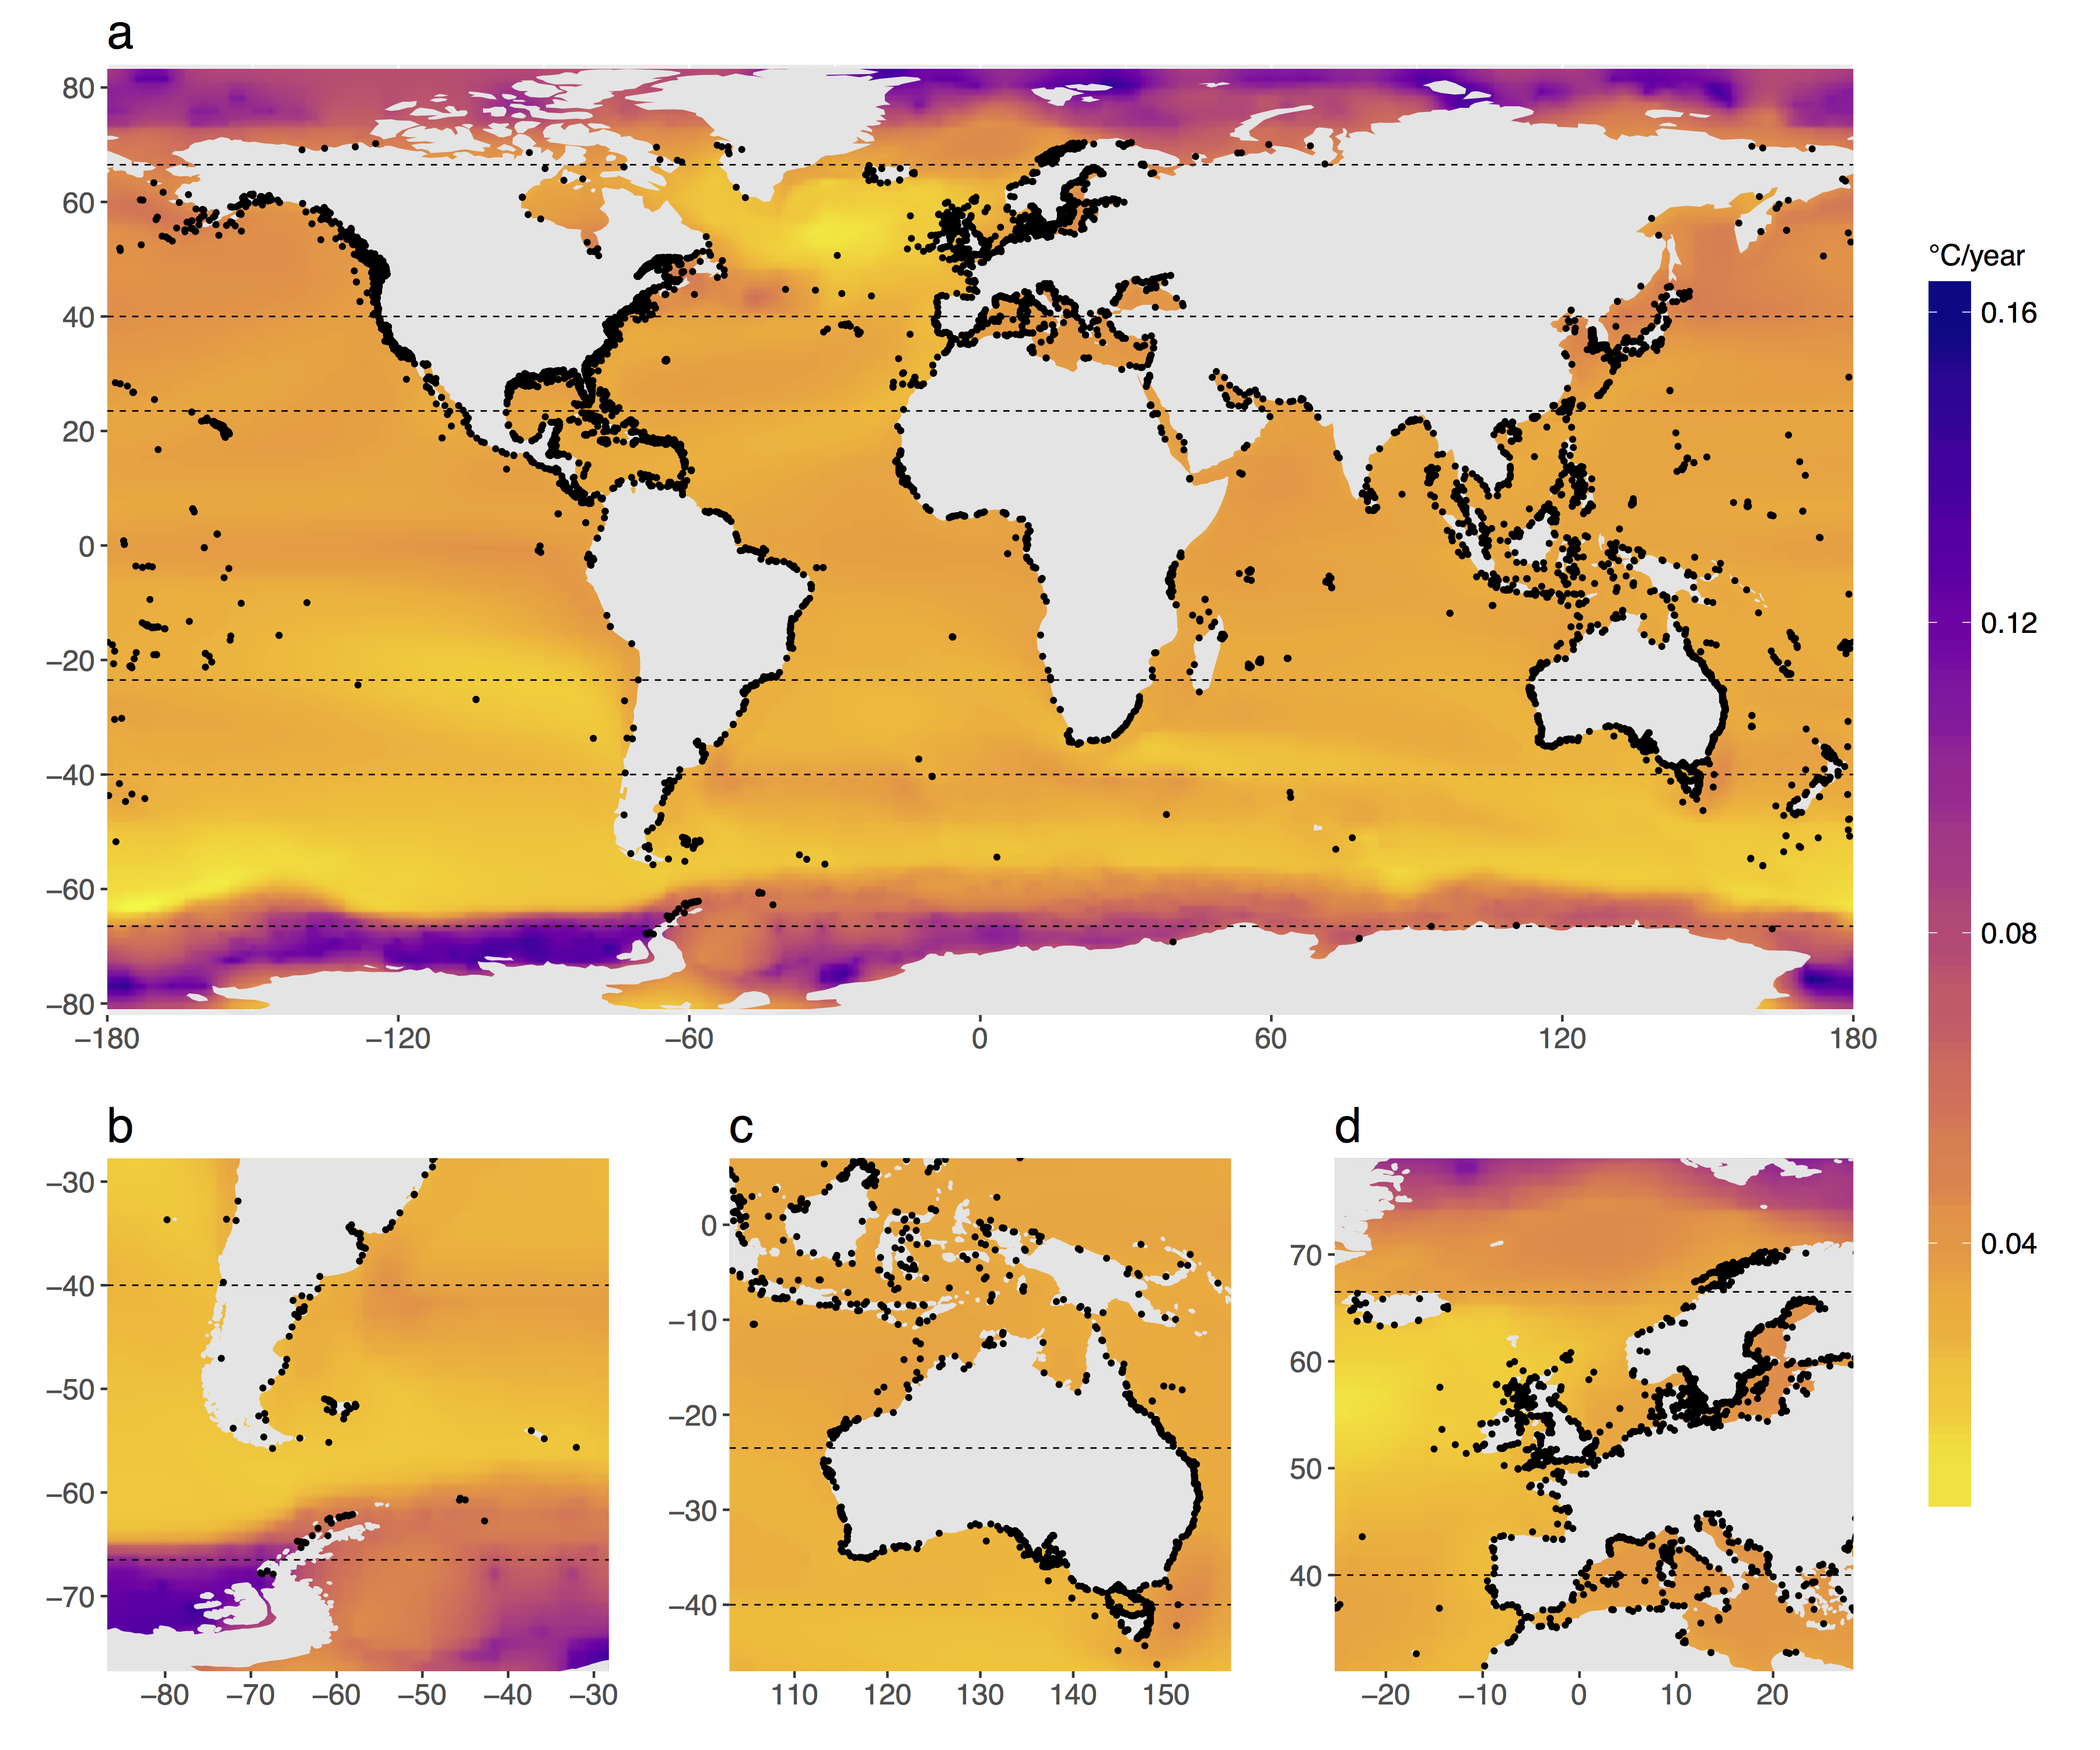

**Figure 1. Patterns of projected ocean warming, 2010–2100.** Changes are SSTs (°C) based on downscaled CIMP3 model outputs under the A2 high-emissions scenario. Black dots indicate the locations (geographic centroids) of MPAs used in the analysis. **a,** Global changes in mean SSTs. **b–c,** Maximum SSTs in 2100 for two tropical regions: **b,** the southwestern Atlantic and **c,** the Coral Triangle. **d**, Changes in maximum SST for one temperate region: the northeastern Atlantic and Mediterranean.

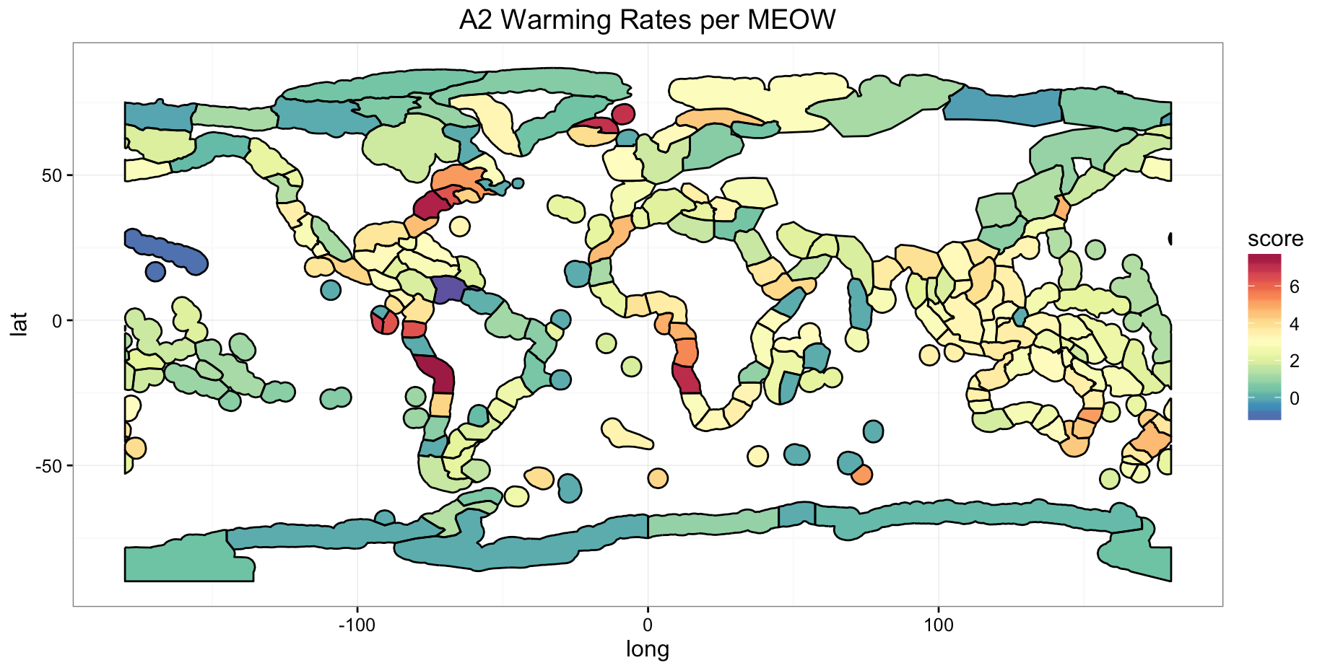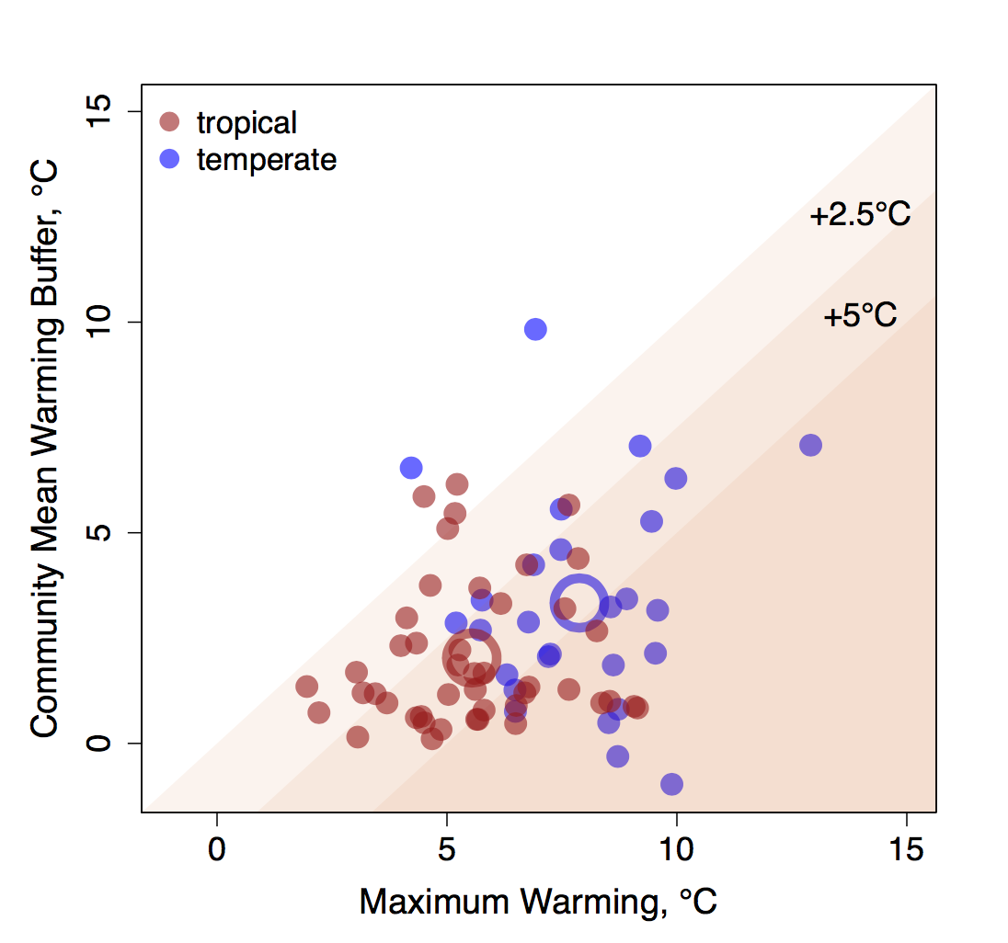

**Figure 3.** **Biodiversity change in marine ecoregions of the world predicted as a function of exposure and sensitivity to warming. top,** Variation in the predicted (A2) increase in maximum SST among ecoregions. Each delineated geographical area is an ecoregion29. Warming rates are the mean of projected rates in MPAs within each ecoregion. **bottom,** A graphical illustration of how the realized effects of predicted increases in maximum MPA SSTs (under scenario A2) in different ecoregions depend on the warming rate (exposure) and ecoregion-specific warming buffer (sensitivity) for reef fishes and mobile invertebrates. Maximum warming is the predicted mean warming rate for all MPAs in each ecoregion (see values in Table S1). The Community Mean Warming Buffer (see complete description in the Supplemental text) is the average maximum temperature across the geographical ranges (determined with 2,447 *in situ* surveys by the Reef Life Survey (RLS) program2) of all species in a community minus the present maximum summertime SST; it is an estimate of how far on average community inhabitants are from their thermal maxima. Each point represents an ecoregion and the larger circles represent mean values for tropical and temperature ecoregions.